Department of Electrical Engineering
The Superior University, Lahore

Computer Programming

Experiment No.6
Implementation of Repetition structures

Prepared for:
Ma’am Eisha Nawaz
By:
Name: Tanseer Haider
ID: SU91-BSEEM-F25-02
Section: Electrical Engineering Fall 25
Semester: 2nd

Total Marks: _______10_________
Obtained Marks: __________________
Signature: __________________
Date: __________________

Experiment No.6
Implementation of Repetition structures
(Rubrics)

Name: Tanseer Haider ID: SU91-BSEEM-F25-02

- PSYCHOMOTOR
Serial No. | Criteria | Allocated Marks | Unacceptable  0% | Poor  25% | Fair  50% | Good  75% | Excellent  100% | Total Obtained
1 | Syntax Handling | 1 | 0 | 0.25 | 0.5 | 0.75 | 1
2 | Program Coding Skills | 2 | 0 | 0.5 | 1 | 1.5 | 2
3 | Accuracy in Output Results | 3 | 0 | 0.75 | 1.5 | 2.25 | 3
Sub-Total |  | 6 | Sub Total Marks Obtained in Psychomotor (P)

- AFFECTIVE
Serial No. | Criteria | Allocated Marks | Unacceptable  0% | Poor  25% | Fair  50% | Good  75% | Excellent  100% | Total Obtained
1 | Assigned tasks | 2 | 0 | 0.5 | 1 | 1.5 | 2
2 | Lab Report | 2 | 0 | 0.5 | 1 | 1.5 | 2
Sub-Total |  | 4 | Sub Total Marks Obtained in Affective (A)

Instructor Name: | EISHA NAWAZ | Total Marks (P+A): | ______10______
Instructor Signature: | ______________ | Obtained Marks (P+A): | ______________
Contents of Lab 6
1 Objectives 4
2 do...while Looping (Repetition) Structure 4
Example 1: 5
3 Introduction to for loop 6
Example 1: 7
Example 2: 7
Example 3: 8
Example 4: 8
Example 5: 8
Example 6: 8
4 Lab Tasks: 9
Task 1: 9
TASK 2 9
5 Home Assignment: 9
Task 1: 9
TASK 2 9
TASK 3 9
TASK 4 10
TASK 5 10
TASK 6 10
TASK 7 10
TASK 8 11

Implementation of Repetition structures

Objectives
      - To get basic understanding repetition looping using do-while loop.
      - To practice how to use do-while loop.
      - To get basic understanding repetition looping using for loop.
      - To practice how to use for loop and nested for loop.

do...while Looping (Repetition) Structure
This section describes the third type of looping or repetition structure, called a do. . .while loop. The general form of a do. . .while statement is as follows:

statement can be either a simple or compound statement. If it is a compound statement, enclose it between braces.
The flow of execution of a do. . .while loop given below.

Figure 1 do-while Loops

Example 1:
Consider the following two loops:
- i = 11;
while (i<= 10)
{
cout<<i<< " ";
i = i + 5;
}
cout<<endl;
- i = 11;
do
{
cout<<i<< " ";
i = i + 5;
}
while (i<= 10);
cout<<endl;

he value of i to 16.

Example 2
Write a program to find the sum of positive numbers. If the user enters a negative number, the loop ends and the negative number entered is not added to the sum.

// Lab_6_Example_2_do...while loop  #include <iostream>  using namespace std;  int main() {  int number = 0;  int sum = 0;  do {  sum += number;  // display the sum  cout << "\nThe sum is " << sum << endl;  // take input from the user  cout << "Enter a number: ";  cin >> number;  }  while (number >= 0);  return 0;  } | Result  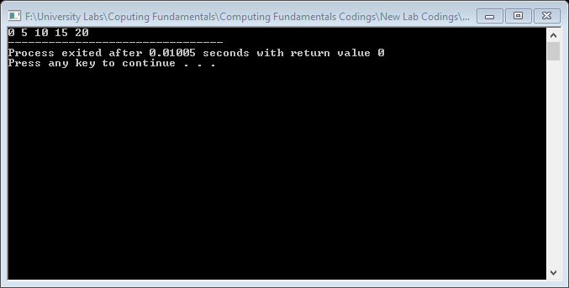

Introduction to for loop
The for loop is typically called a counted or indexed for loop. The general form of the for statement is:

The initial statement, loop condition, and update statement (called for loop control statements) enclosed within the parentheses control the body (statement) of the for statement.

Figure 2 for Loop
The for loop executes as follows:
- The initial statement executes.
- The loop condition is evaluated. If the loop condition evaluates to true:
  - Execute the for loop statement.
  - Execute the update statement (the third expression in the parentheses).
- Repeat Step 2 until the loop condition evaluates to false.
The initial statement usually initializes a variable (called the for loop control, or for indexed, variable).

Example 1:
1 | // Lab_6_Example_1_for loop  #include<iostream>  using namespace std;  intmain()  {  int counter;  for (int counter=0; counter<=5; counter++)  cout<<counter;  return 0;  } | Result  0 1 2 3 4 5
2
3
4
5
6
7
8
9
10
11
12

The initial statement, counter = 0;, initializes the int variable counter to 0. Next, the loop condition, counter<=5, is evaluated. Because 0 <=5 is true, the print statement executes and outputs 0. The update statement, counter++, then executes, which sets the value of i to 1. Once again, the l oop condition is evaluated, which is still true, and so on. When counter becomes 5, the loop condition evaluates to false, the for loop terminates, andthe statement following the for loop executes.

Example 2:
// Lab_6_Example_2_for loop  #include<iostream>  using namespace std;  int main()  {  int i;  for (i=0; i<=5; i++)  cout<<"Welcome to class"<<"\n";  cout<<"*";  return 0;  } | 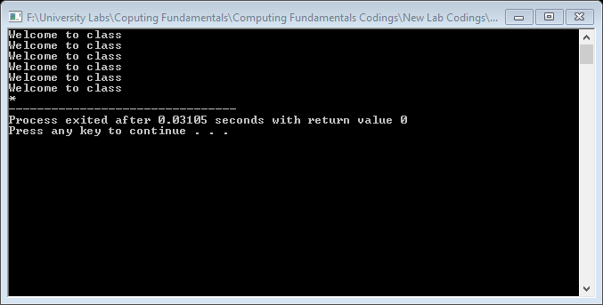  Result
This loop outputs Hello! five times and the star only once. Note thatthe for loop controls only the first output statement because the two output statements are not made into a compound statement.

Example 3:
// Lab_6_Example_3_for loop  #include<iostream>  using namespace std;  int main()  {  inti;  for (i=0; i<=5; i++)  {  cout<<"Welcome to class"<<"\n";  cout<<" * ";  }  return 0;  } | Result  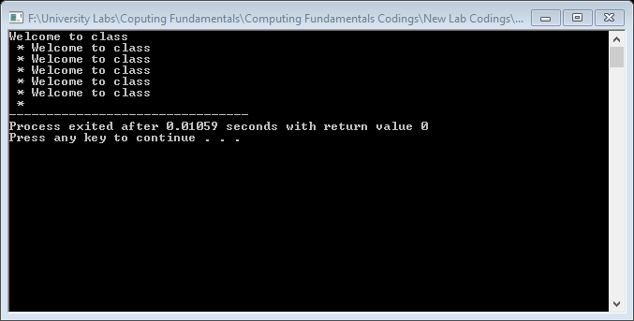

Example 4:
Execute the following programs and write the results in Result column.
for (i = 10; i<= 9; i++)  cout<<i<< " ";  cout<<endl; | Result

Example 5:
for (i = 9; i>= 10; i--)  cout<<i<< " ";  cout<<endl; | Result

Example 6:
// Lab_6_Example_3_for loop  #include<iostream>  using namespace std;  int main()  {  inti;  for (i=0; i<=5; i++)  {  cout<<"Welcome to class"<<"\n";  cout<<" * ";  }  return 0;  } | Result  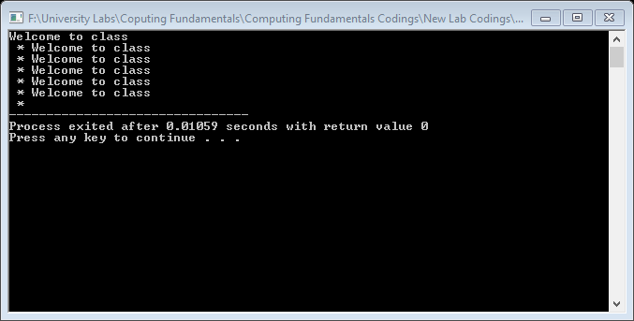

Lab Tasks:
Theme: A single-phase voltage-quality monitor and an energy meter built on a microcontroller super-loop.
Task 4.1: Voltage Sampling Monitor (do–while)
Read line-voltage samples (V) until a negative sentinel (not counted). Track count, sum, min, max. With NOMINAL=230, print OVER-VOLTAGE if >240 and UNDER-VOLTAGE if <220. Print stats afterwards; guard count==0.
Goal: do–while sentinel control + accumulator pattern.
Task 4.2: Load Power Table (for)
With a single for loop, print current 1..10 A and power P = 230 × I in two aligned columns.
Goal: counted iteration + formatted tables.
Task 4.3: Three-Phase Sample Grid (nested for)
Read N (≤ 8). Print values for three phases R, Y, and B, where:
$$\text{value}=(\text{phase number})×10+\text{step}$$
- Phase R = 1 → values: 10 + step
- Phase Y = 2 → values: 20 + step
- Phase B = 3 → values: 30 + step
Display each phase on a separate labeled row using simple for loops (no nested loops).
Lab 6 Starter Code
File: ee_lab6.cpp. Fill in every TODO;
#include <iostream>
#include <iomanip>
#include <limits>
using namespace std;
const int NOMINAL = 230;
void voltageMonitor(){
int count=0; double sum=0,v,mn=numeric_limits<double>::max(),mx=numeric_limits<double>::lowest();
do{
cout<<"Voltage sample (negative to stop): "; cin>>v;
// TODO 4.1a: if v>=0 update count,sum,mn,mx
// TODO 4.1b: print OVER (>240) / UNDER (<220) voltage alerts
}while(/* TODO 4.1c */ false);
// TODO 4.1d: print count,avg,mn,mx (handle count==0)
}
void powerTable(){
cout<<setw(12)<<"Current(A)"<<setw(12)<<"Power(W)"<<endl;
// TODO 4.2: for I=1..10 print I and 230*I
}
void phaseGrid(){
int N; cout<<"Steps N (<=8): "; cin>>N; const char* ph="RYB";
// TODO 4.3: for; print (phase+1)*10+step (setw 5); label ph[phase]
}
int main(){int c;do{cout<<"\n1)Monitor 2)PowerTable 3)PhaseGrid 0)Exit\nChoice: ";cin>>c;
if(c==1)voltageMonitor();else if(c==2)powerTable();else if(c==3)phaseGrid();}while(c!=0);return 0;}

4.1
input: 225 245 218 230 -1
*** OVER-VOLTAGE: 245 V ***
*** UNDER-VOLTAGE: 218 V ***
Count:4 Avg:229.5 Min:218 Max:245
4.2
output (head):
Current(A) Power(W)
1 230
2 460
10 2300
4.3
N=4:
R: 11 12 13 14 15
Y: 21 22 23 24 25
B: 31 32 33 34 35

Home Assignment:
Read half-hourly kWh readings until the sentinel value -1.
- Read one reading at a time until -1.
- Calculate the total energy consumed (kWh).
- Find the highest reading (peak interval) and its interval number.
- Apply the slab tariff:
  - First 100 kWh @ Rs. 10 per kWh
  - Next 200 kWh @ Rs. 16 per kWh
  - Remaining units @ Rs. 22 per kWh
- Count intervals where consumption exceeds PEAK_LIMIT = 5 kWh.
- Add a surcharge of Rs. 50 for each interval above the limit.

Print:
  - Total kWh
  - Peak reading and interval number
  - Charges for each slab
  - Total surcharge
  - Final bill amount
- Bonus: Calculate average load in kW using:
$$\text{Average Load}=\frac{\text{Total kWh}}{\text{Number of Intervals}×0.5}$$
Dataset (then -1):
1.2 3.5 6.1 2.0 5.5 0.8 4.4 7.2 2.1 -1
